Practical – 4

Introduction to Libre Project

Project Name: Online Car Rental System

Manager: Chandarana Shyam

Start Date: March 17th, 2022 Notes: This is demo project

# Tasks

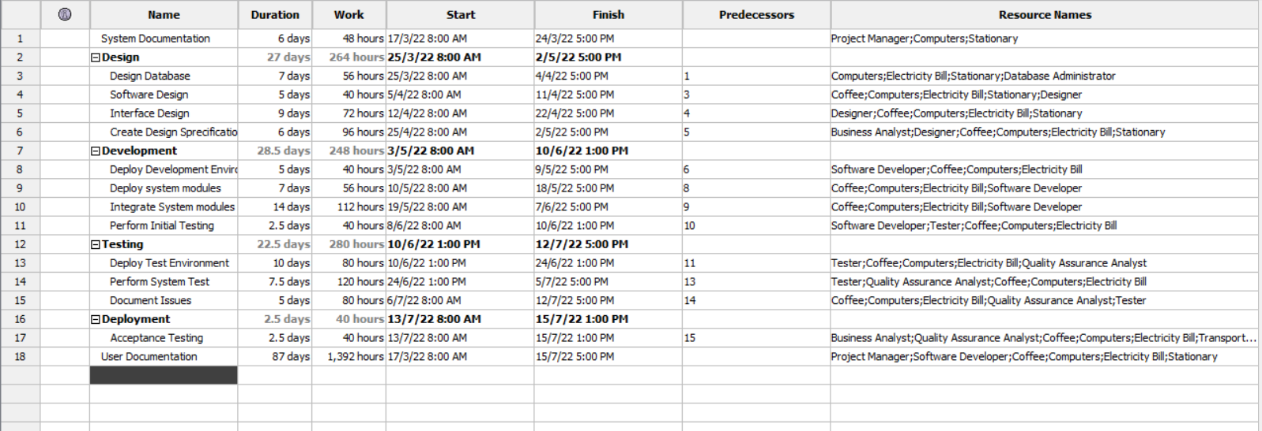

Mainly, there are five tasks available, inside the task’s subtasks are present with there working hours, total number of working days required to complete that particular task and with its starting and ending dates. Predecessors shows the connection between the tasks like after completing the task which task should start. Resource name column shows the assignment of the resource to that particular task.

# Gantt Chart

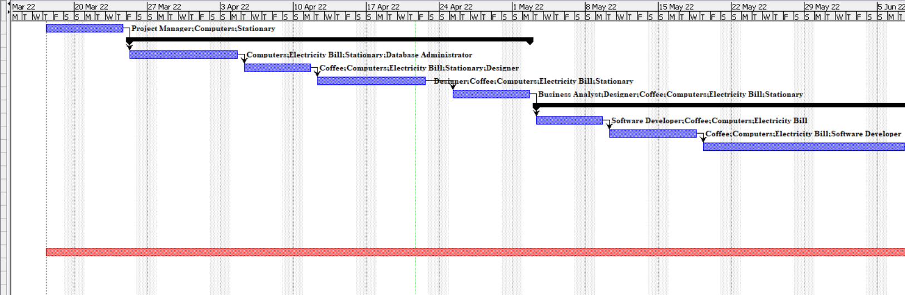

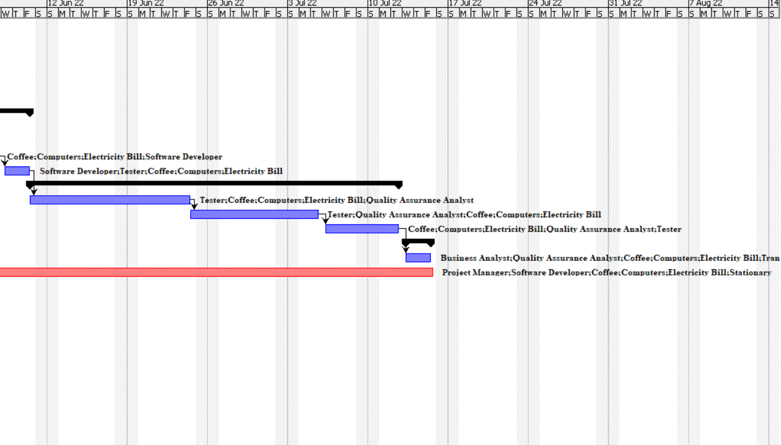

This Gantt Chart shows the timeline of the project. In which it displays the timeline of the particular tasks and its subtasks with the resource assignment labelling in it and even connectors are also present in it which shows about the connection between the tasks like after complete a particular task which task need to get start.

# Resources

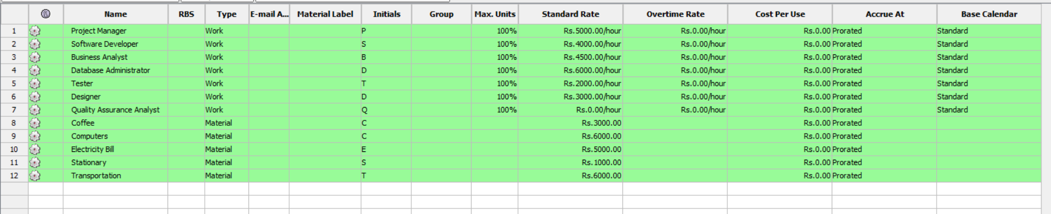

This image shows all the resources available resources in the project in the form of work and material. Work like project manager, software developer, business analyst, database administrator, tester, designer and quality assurance analyst. Material like coffee, computer, electricity bill, stationery and transportation charges to be done while the development of the project.

# Resource assignment

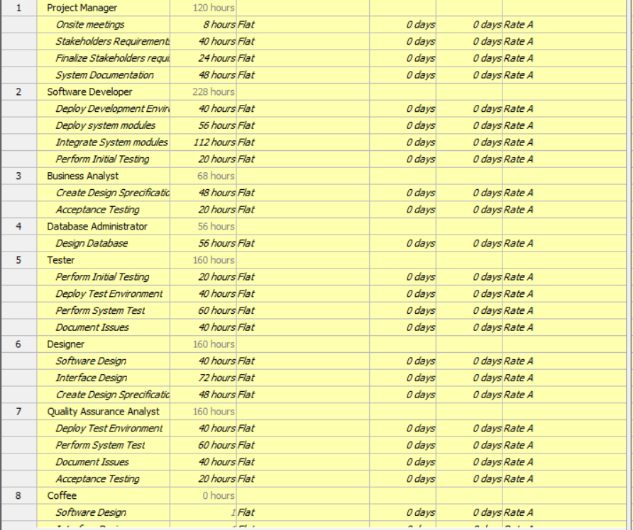

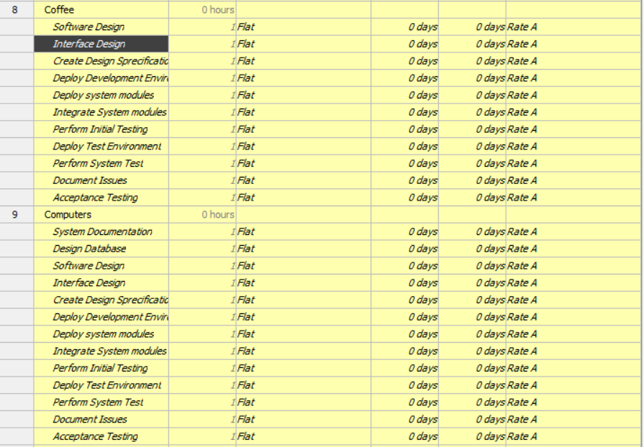

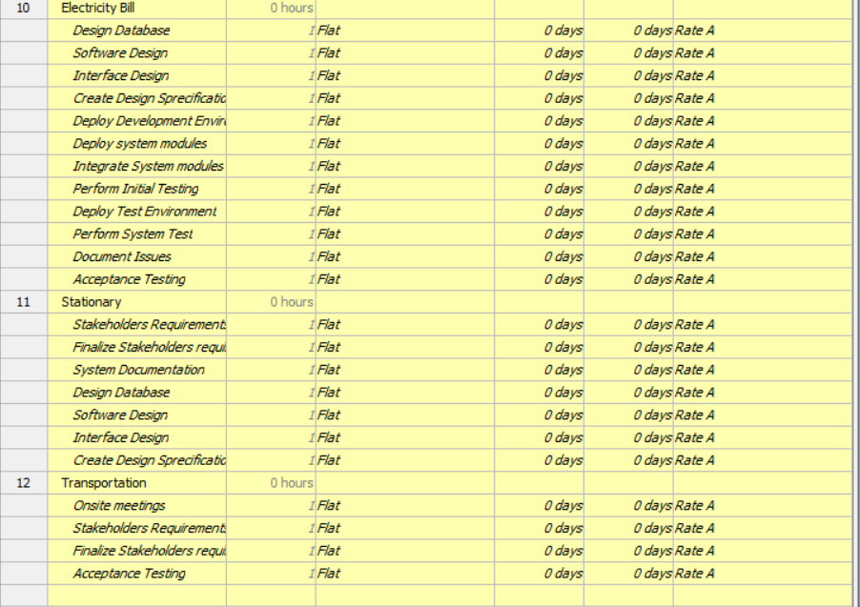

This resource assignment shows about the tasks which has been assign to the resource in the form of hours and cost.